Stock Price Prediction using LSTM & ANN

In this project we are using LSTM and ANN algorithms to predict stock prices and we trained both algorithm in different stock prices such as TATA, TESLA, Facebook, Apple etc. In both algorithm ANN is giving high accuracy and less Mean Square Error (MSE).

We have experiment both algorithms on above mention different stock prices and both algorithm showing close and accurate prices of original test data. We have splitted dataset into train & test where application using 80% dataset size for training and 20% for testing

To implement this project we have used same dataset given in your requirement file and to implement this project we have designed following modules

1. Upload Stock Price Dataset: using this module we will select STOCK Name and then upload dataset and application will extract all records from selected stock name and then sort dataset in ascending date order and then plot stock price history graph
2. Preprocess Dataset: using this module we will remove missing values and then normalize stock values using MINMAX SCALER algorithm and then split dataset into train and test. 80% dataset using for training and 20% for testing
3. Run ANN Algorithm: using this module we will input 80% dataset to ANN algorithm to train a model and this model will be applied on 20% test data and then calculate difference between actual stock test price and predicted price as MSE error.
4. Run LSTM Algorithm: using this module we will input 80% dataset to LSTM algorithm to train a model and this model will be applied on 20% test data and then calculate difference between actual stock test price and predicted price as MSE error.
5. MSE Comparison Graph: using this module we will plot MSE comparison graph between both algorithms

To implement above modules we have used below 2 datasets

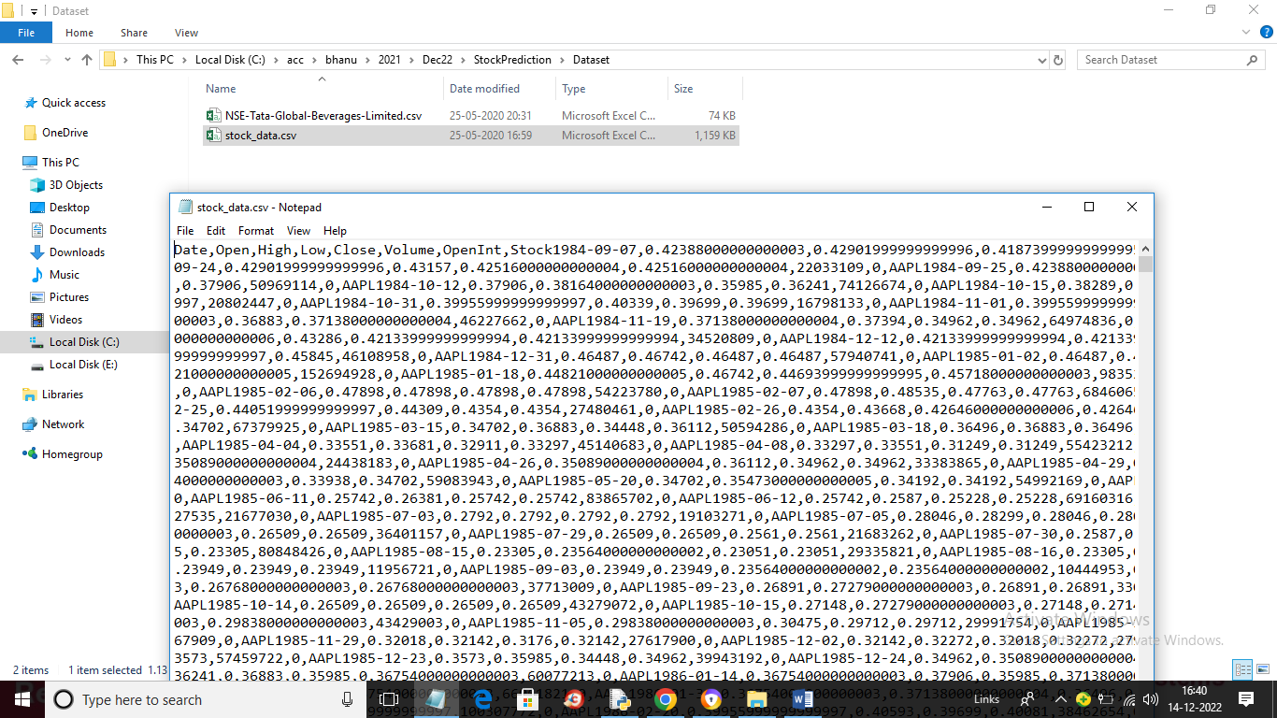

SCREEN SHOTS

To run project double click on ‘run.bat’ file to get below screen

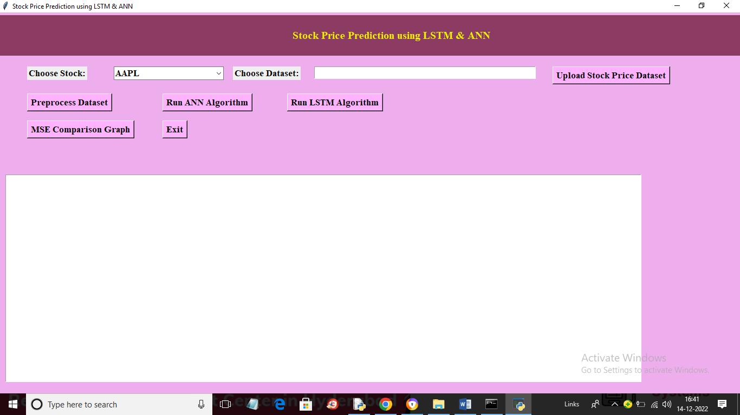

In above screen choose stock name from drop down box and then click on ‘Upload Stock Price Dataset’ button to upload dataset and get below output

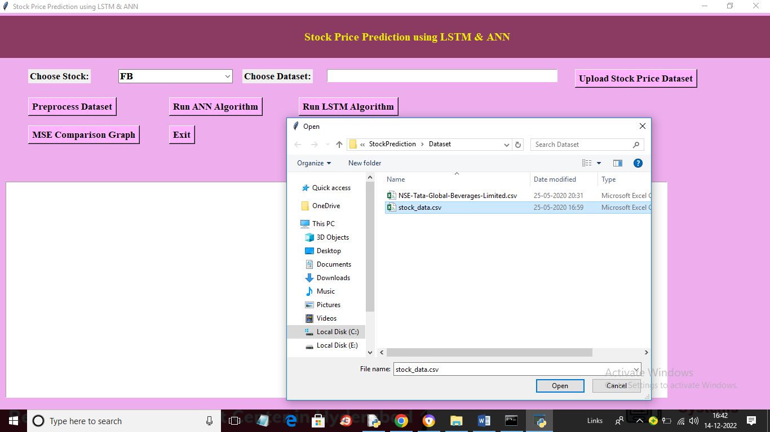

In above screen I selected stock name as ‘FB’ and then uploading ‘stock_data.csv’ file and then click on ‘Open’ button to load dataset and get below output

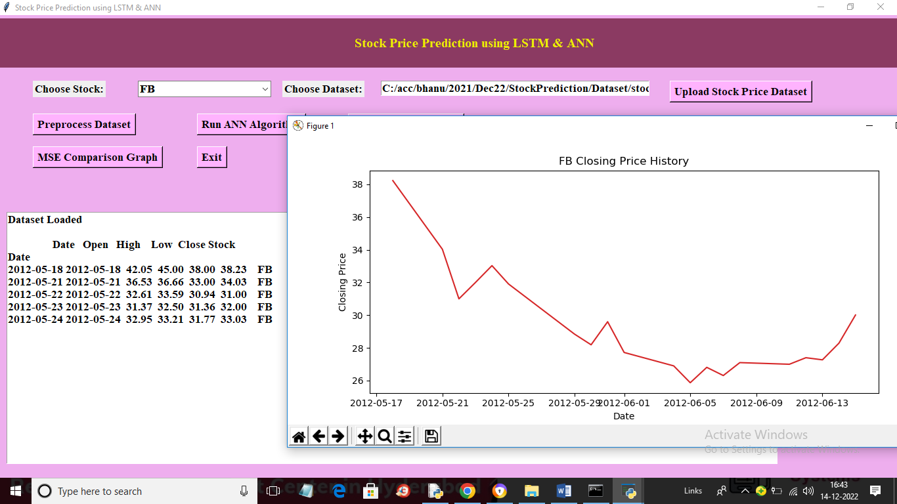

In above screen dataset loaded and in graph we can see stock history prices on different dates where x-axis contains DATE and y-axis represents stock price on that date. Now close above graph and then click on “Preprocess Dataset’ button to normalize dataset values and then split into train and test

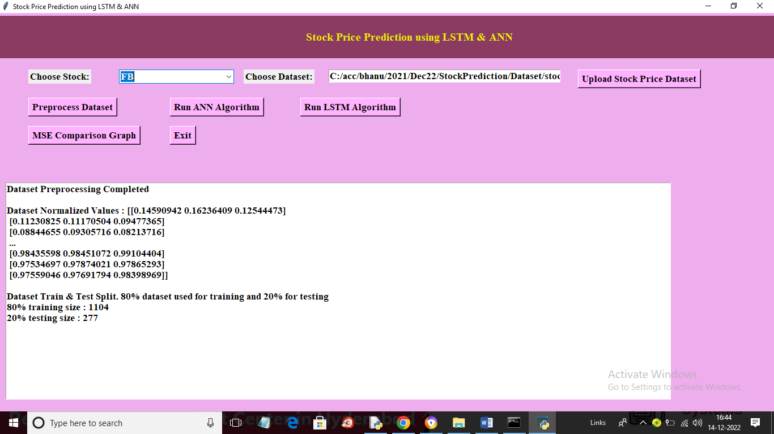

In above screen we can see normalized dataset values and then we can see 80% training records size and 20% testing records size and now click on ‘Run ANN Algorithm’ button to train ANN and get below predicted prices

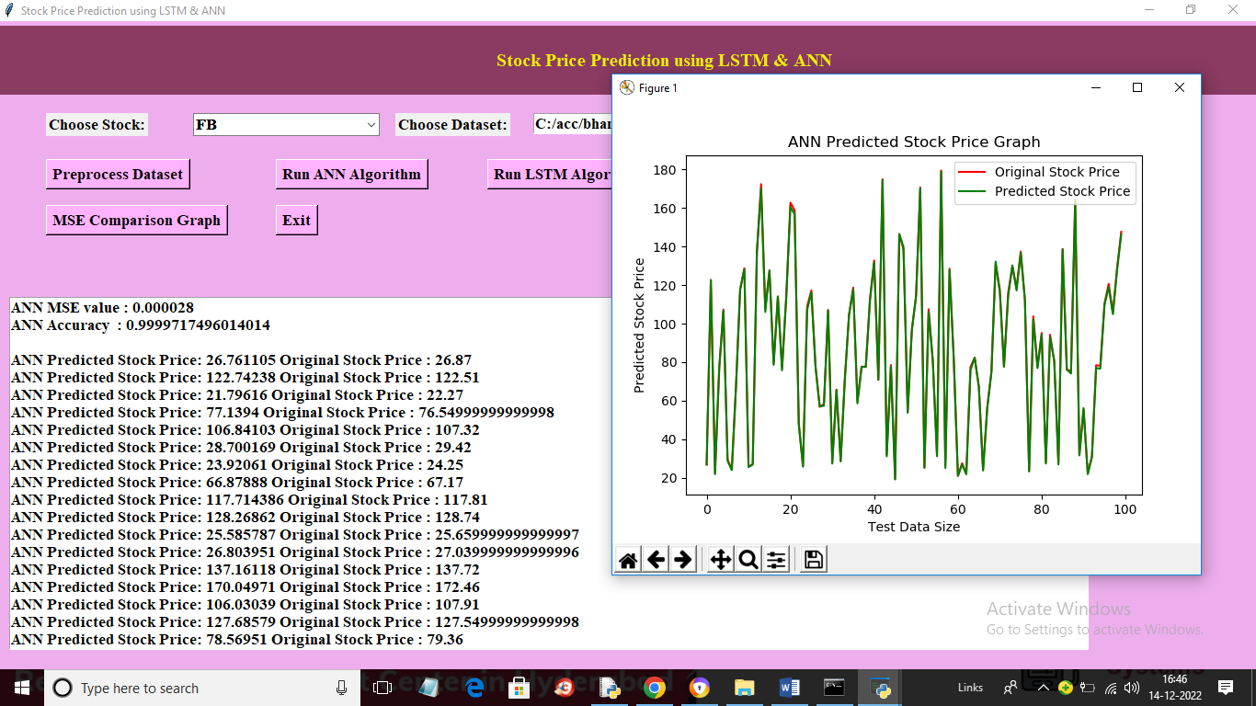

In above screen in first 2 lines we can see ANN MSE value (the lower the MSE the better is the algorithm) and we can see accuracy also and then in next lines we can see ANN predicted prices and original 20% test data prices and we can see both prices are too close and in graph x-axis represents TEST data DAYS and y-axis represents STOCK PRICES and green line represents PREDICTED prices and red line represents ORIGINAL STOCK prices and we can see both lines are fully overlapping so predicted and test prices are too close and accurate. Now close above graph and then click on ‘Run LSTM Algorithm’ button to get below output

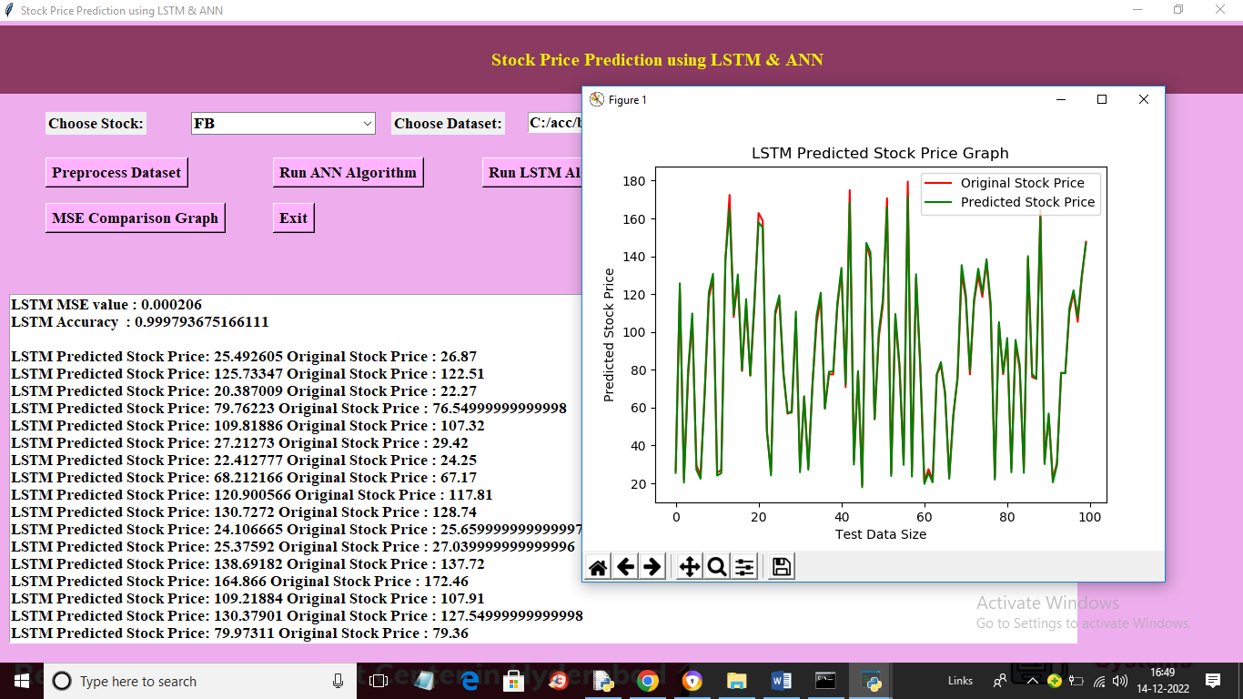

In above screen we can see LSTM predicted prices with MSE and accuracy values and we can see LSTM MSE is little higher than ANN but its predicted also too close as LSTM graph values are also overlapping with TEST prices. Now click on “MSE Comparison Graph’ button to get below graph

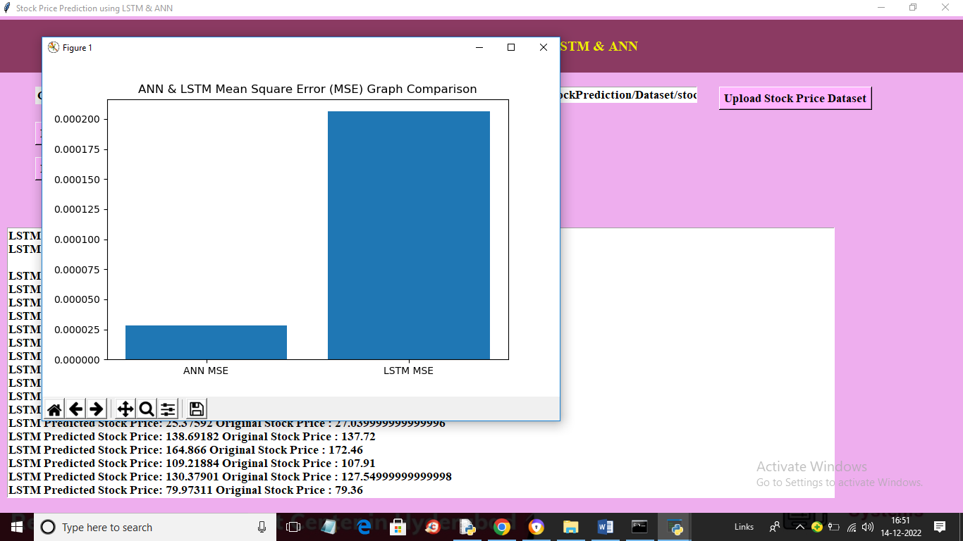

In above graph x-axis represents algorithm names and y-axis represents MSE values and in both algorithms ANN got less MSE compare to LSTM so we can say ANN is better than LSTM. Similarly you can upload other dataset and select stock name and predict prices